
ABES ENGINEERING COLLEGE GHAZIABAD
LAB MANUAL
(2024-2025)
CNC LAB
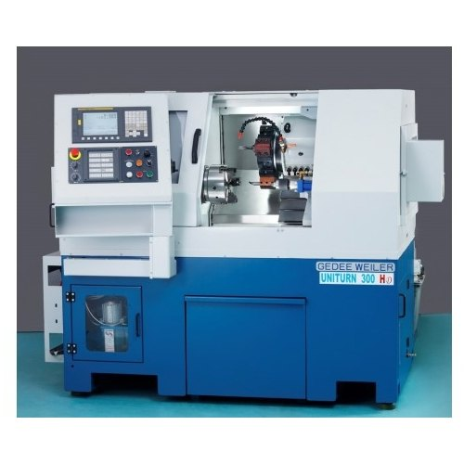
(CNC LAB, Ramanujan Block,Ground Floor)

  - Mr. Dinesh Patharia Prof. ( Dr. ) R.S. Raman
  - (Lab Coordinator) (HOD – ME)


Dr. A.P.J ABDUL KALAM TECHNICAL UNIVERSITY, LUCKNOW
  - Machine Specification( CNC Turnning Center)
Product Type | Uniturn 300HD CNC Lathe Machine
Max Turning Dia | 100mm
Max.turning Length | 250 mm
Chuck size | 165mm
Spindle Nose/Power/RPM | A2-5 /5 LB/5.5/7kw/40-4000rpm
Travel X axis/Z axis | 250 mm /360mm
Rapid X axis/Z axis | 20mm/25
No.of Turning Tool | 5
Tool size(Cross section) | 20 x20
No.of Boring Tool | 3
Tailstock Quill dia / Stroke / Taper | 50mm / 125mm / MT 4
CNC Control system | Mitsubishi E70,  Siemens 828D, Fanuc OI Mate TF

TURRET
1 | NO OF TOOL | 8
2 | TOOL SHANK SIZE | 20X20 MM
3 | MAX.BORING BAR SIZE | 32 MM

POWER
1 | SPINDLE POWER | 5.5/7.5 KW
2 | HYDRAULIC POWER PACK | 2.2 KW

ACCURACY
1 | POSITION X-AXIS | 0.005 MM
2 | POSITION Z- AXIS | 0.008 MM
3 | REPEATABILITY X- AXIS | 0.002 MM
4 | REPEATABILITY Z- AXIS | 0.002 MM

INTRODUCTION
Definition of CNC: - Computer Numerical Control (CNC) is one in which the functions and motions of a machine tool are controlled by means of a prepared program containing coded alphanumeric data. CNC can control the motions of the work piece or tool, the input parameters such as feed, depth of cut, speed, and the functions such as turning spindle on/off, turning coolant on/off.
Applications -The applications of CNC include both for machine tool as well as non- machine tool areas. In the machine tool category, CNC is widely used for lathe, drill press, milling machine, grinding unit, laser, sheet-metal press working machine, tube bending machine etc. Highly automated machine tools such as turning centre and machining centre which change the cutting tools automatically under CNC control have been developed. In the non-machine tool category, CNC applications include welding machines (arc and resistance), coordinate measuring machine, electronic assembly, tape laying and filament winding machines for composites etc.
CNC (Computer Numerical Control):
Automatic operation became much more flexible when easily programmed computers were linked to NC machines.
This so called ‘Computerized Numerical Control’ (CNC for short) still involves NC: it is
only the addition of the computer that is new, making flexible programming possible.
A CNC system can be used with many different types of machines. This is possible because the CNC can use different system programs. Each different program enables the CNC to control another type of machine.
Advantages:
A CNC machine has number of advantages:
- Programs can be entered directly to the machine;
- Programs can be stored in its memory;
- Programs can be amended subsequently
- Dimensions of tools and clamping devices can be entered into the computer; 5-High accuracy and more productivity.
6-Additional products can be made with relatively few tools. 7- Reduced human error
TYPES OF CNC MACHINE
1. Slant Bed CNC Lathe
Description:
The bed is angled (usually 30° or 45°).
Offers better chip removal, tool accessibility, and rigidity.
Common in high-speed and high-precision machining.
Advantages:
- Improved cutting visibility
- More rigid construction
- Better coolant and chip evacuation
2. Turret CNC Lathe (Horizontal or Vertical)
Description:
- Has a rotating turret that holds multiple tools.
- Used for high-speed automated production.
- Available in both horizontal and vertical configurations.
Advantages:
- Multiple tools for complex operations
- Faster tool changes
- Ideal for medium to high-volume production
3. Swiss-Type CNC Lathe
Description:
- Used for small, long, precision parts.
- The bar stock moves, and tools are fixed.
- Features a guide bushing close to the cutting tool.
Advantages:
- Ultra-high precision
- Great for small, complex parts (e.g., medical or watch parts)
- Can run unattended for long periods
Key Components of CNC Turret Lathe
CHUCK
It is a device that holds a work piece in place as it rotates. The chuck commonly has three or four jaws that can be adjusted to fit various sizes.

Types:-
According to clamping system
- Hydraulic chuck
- Magnetic chuck
- Pneumatic chuck
Most commonly used chuck is Hydraulic chuck.
According to Jaw
- Two jaw chuck
- Three jaw chuck
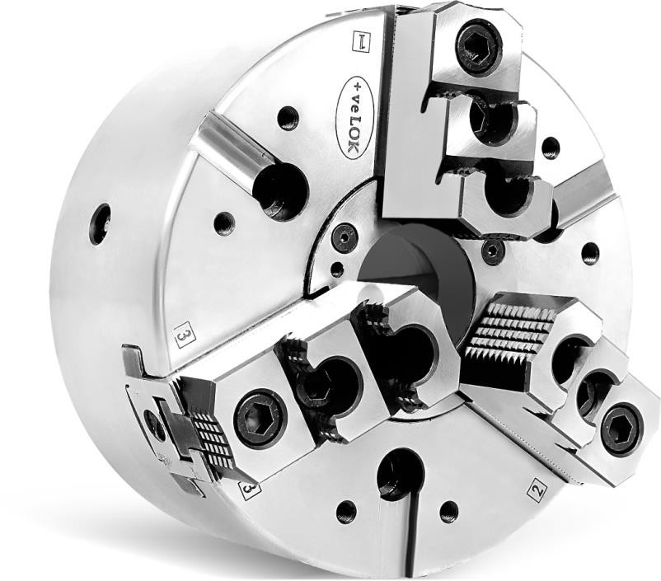
- Four jaw chuck
Changeable Jaw
Master Jaw
Nipple
Chuck Body

TURRET
It is the component of a lathe that holds a number of cutting tools. The turret indexed itself to place the tools in the according to the program. Mostly turret having 8 tool stations.
Common Types of Turret:-
- Hydro-magnetic
- Electromagnetic
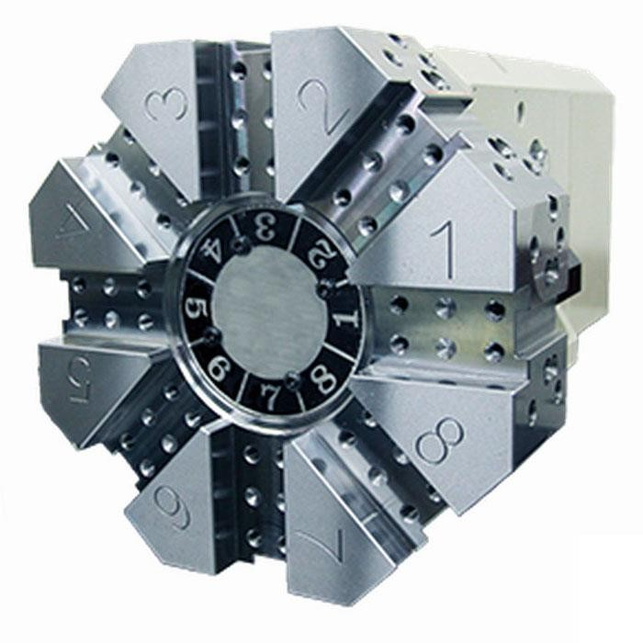
Tailstock
It is usually used to apply support to the longitudinal rotary axis of a work piece being machined. A lathe centre is mounted in the tailstock, and inserted against the sides of a hole in the centre of the work piece. A tailstock is particularly useful when the work piece is relatively long and slender. Failing to use a tailstock can cause "chatter," where the work piece bends excessively while being cut.
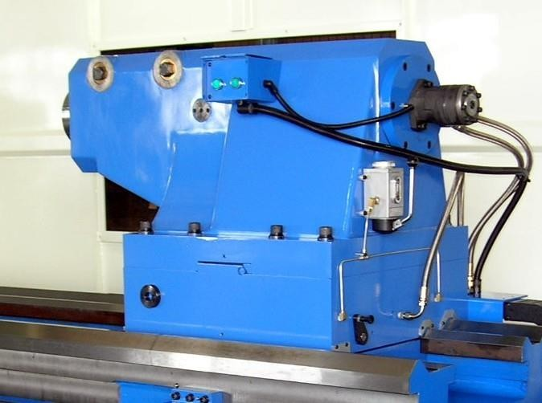

Foot-Switch
A footswitch is a rugged switch which is operated by foot pressure. An example of use is in the control of a machine tool, allowing the operator to have both hands free to manipulate the work piece.
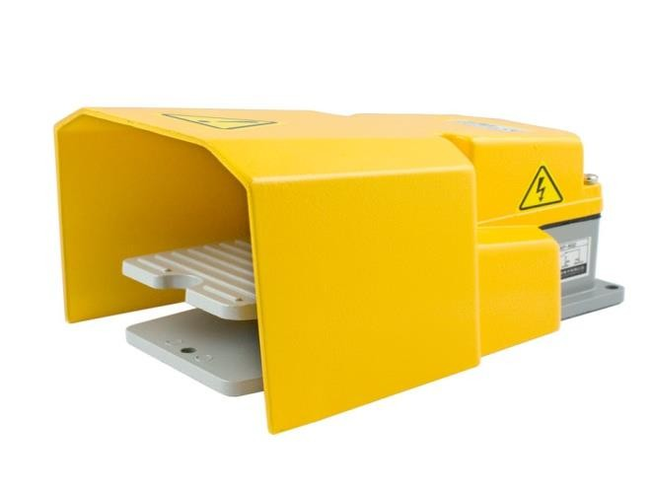

Hydraulic Tank
A fundamental feature of hydraulic systems is the ability to apply force or torque multiplication in an easy way, independent of the distance between the input and output, without the need for mechanical gears or levers, either by altering the effective areas in two connected cylinders or the effective displacement (cc/rev) between a pump and motor. In normal cases, hydraulic ratios are combined with a mechanical force or torque ratio for optimum machine designs such as boom movements and track drives for an excavator.
In CNC Turning centre we use hydraulic pressure in chuck and tailstock for clamp and unclamp.
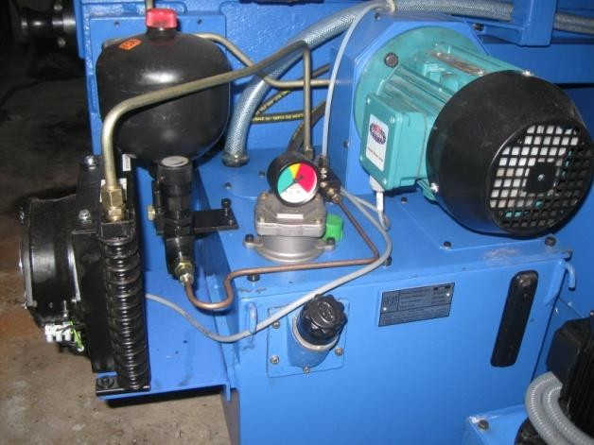
Hydraulic oil – Servo system 68

LUBRICATION SYSTEM-
An automatic lubrication system (ALS), often referred to as a centralized lubrication system, is a system that delivers controlled amounts of lubricant to multiple locations on a machine while the machine is operating.
We use the Lubrication oil-Servo system 32
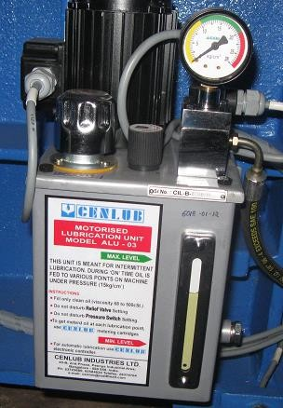
z
Oil Label Indicator
Pressure Gauge
Pump

Benefits:
Auto lube systems have many advantages over traditional methods of manual
lubrication:
- All critical components are lubricated, regardless of location or ease of access
- Lubrication occurs while the machinery is in operation causing the lubricant to be equally distributed within the bearing and increasing the machine’s availability.
- Proper lubrication of critical components ensures safe operation of the machinery.
- Less wear on the components means extended component life, fewer breakdowns, reduced downtime, reduced replacement costs and reduced maintenance costs
- Measured lubrication amounts means no wasted lubricant
- Safety - no climbing around machinery or inaccessible areas (gases, exhaust, confined spaces, etc.)
- Lower energy consumption due to less friction
- Increased overall productivity resulting from increase in machine availability and reduction in downtime due to breakdowns or general maintenance
- in this system lubrication the engine parts are lubricated under pressure feed
COOLANT TANK
It supplies the coolant to various parts of the machine so that machine part does not get heated.
the program execution when called by program words M08 and M09 respectively.
Coolant = Cutting Oil + DM Water Ratio = (1 : 20) LTR.

CONTROL PANEL
Control all the function performed by the machine. All the changes and control of various parts of the machine are done by the control panel.
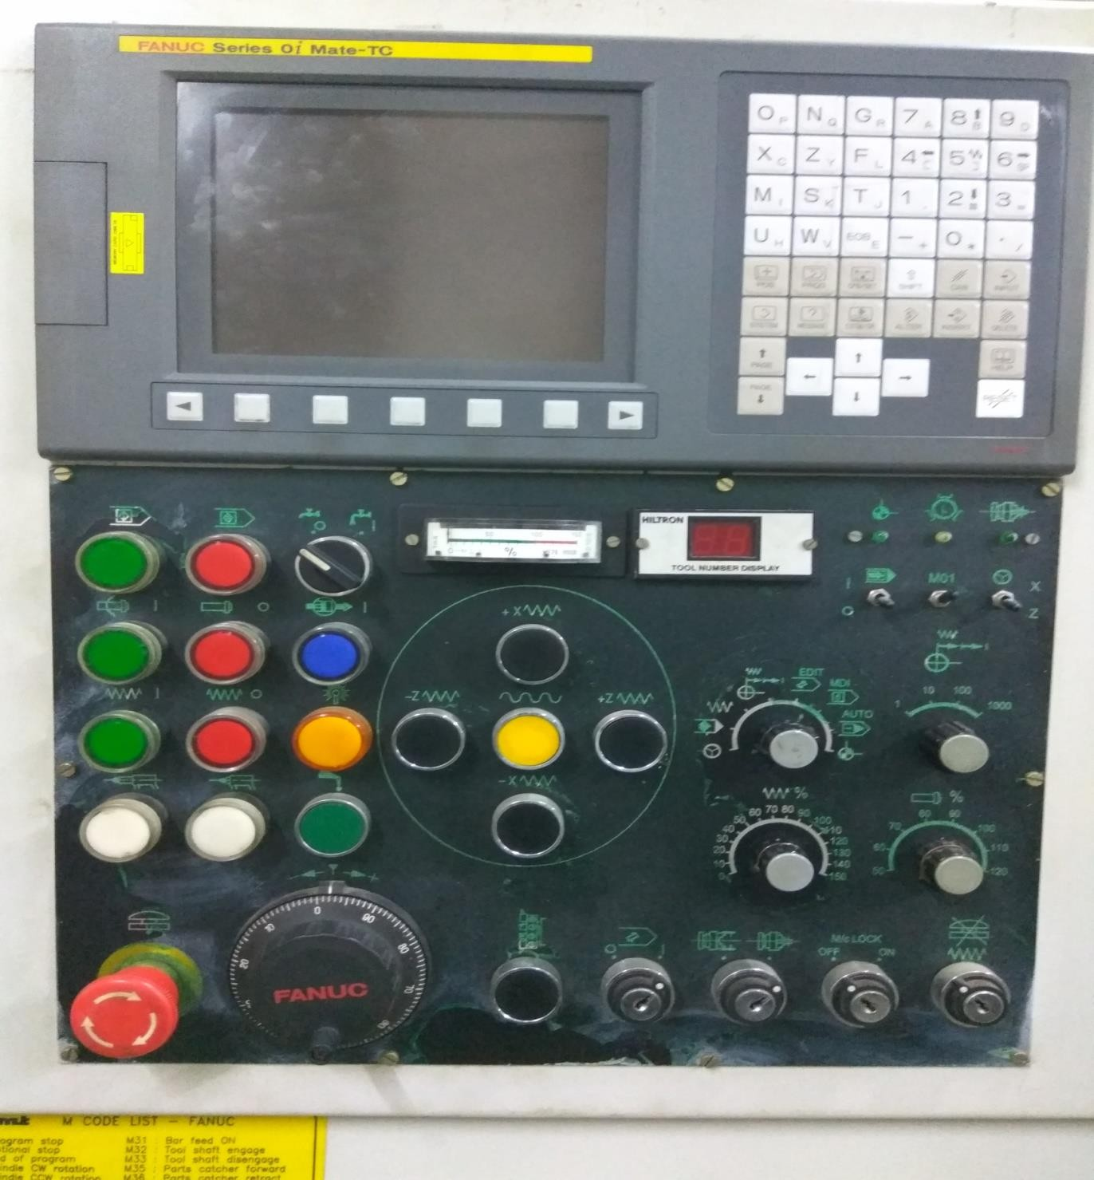

Description of Control Panel

MODE SELECTION SWITCH:
This switch is used for selecting different kind modes of reading or executing the program. The description of different kind of modes is given as below:
  - Auto Mode:- In this type of mode, programs are registered in memory in advance. When one of these programs is selected and cycle start switch on the machine operator’s panel is pressed, automatic operation starts, and the cycle LED goes on.
  - Single Auto Mode:- This mode is similar to the Auto mode with a difference that it takes or read the program one by one block. After reading the first block, then it goes to the next block.

  - Handle Mode :- This kind of mode is a manual mode in which the machine tool moves with the help of MPG(Manual Pulse Generator)

  - MDI Mode:- This mode is known as Manual Data Input mode. In this mode, a program consisting of up to 10 lines can be created in the same format as normal programs and executed from the MDI panel. MDI operation is used for simple test operations.
  - Jog Mode:- In this mode, pressing a feed axis and direction selection switch on the machine operator’s panel continuously moves the tool along the selected axis in the selected direction.
  - Zero Return:- In this mode, the machine tool goes to its origin of the coordinate system.
II- FEEDRATE OVERRIDE:
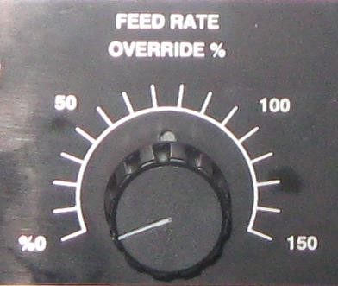
This switch is used for controlling the feed rate of the machine axis. A programmed feed rate can be reduced or increased by a percentage selected by the override dial.

NOTE: 1- This function is only active in case of Auto, Jog and Reference mode.
2- During threading, the over-ride is ignored and feed-rate remain as specified by program
- SPINDLE SPEED OVERRIDE
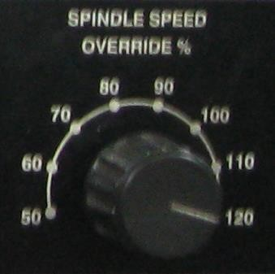
Spindle Speed Over-ride selector switch is used to over-ride the programmed speed within the range 50 to 120% of the programmed spindle speed. The amount of override selected will affect all machining processes until it is changed.

Program Control Keys/Buttons:
These are also known as conditional switches that determine how the machine reacts during automatic and manual operation. They could be toggle switches, locking push buttons etc.
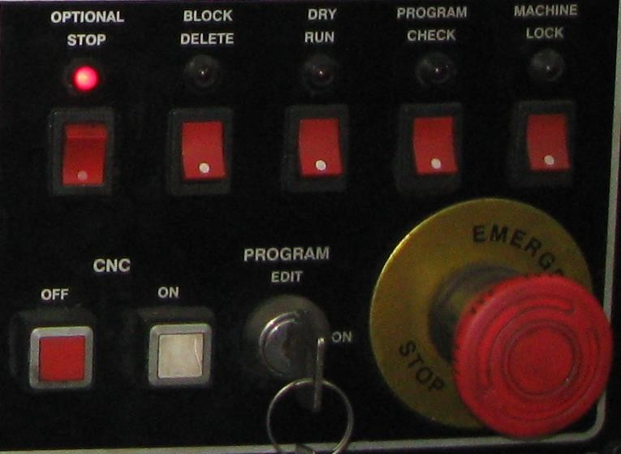
  - Dry Run: It is a conditional switch typically used with programs during the verification process. With this switch on, the operator controls the motion rate at which the machine will move.
  - Single Block: Single block allows an active part program to be processed one block at a time. When this feature is active each block must be started using the CYCLE START pushbutton.
  - Block Delete: It is a conditional switch that works in combination with slash codes ( / ) in the program. On switching on this button, the control ignores thecommand in which the slash code is included and on switching off, the control executes the command.
  - Optional Stop: Optional Stop feature is enabled by M01. When optional stop is active the CNC cycle will stop on reading an M01 code and can only be re- started by pressing the CYCLE START pushbutton.
  - Emergency Stop: This button interrupts the current to the motor. If this button is pressed, machine movement stops in a moment. This button is locked when it is pressed. Although it varies with machine tool builder, the button can usually be unlocked by twisting it.
  - Machine Lock: There are two types of machine lock, all axis machine lock, which stops the movement along all axes, and specified- axis machine lock, which stops the movement along specified axis. On pressing this button, the tool does not move but the position along each axis changes on the display as if the tool were moving.
  - Program Edit: This function is activated or deactivated with the help of a key. On deactivating this function with the help of key i.e. making it in OFF condition, program cannot be edited. The program can only be activated by making this function in ON condition with the help of key.

Jog Feed
In the jog mode, pressing the feed axis and direction selection switch on the machine operator’s panel continuously moves the tool along the selected axis in the selected direction.
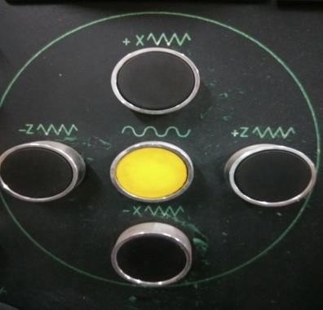
III - Soft Keys
The Keyboard pads and soft keys are used to input instructions to the control. Existing program can be modified or deleted, new programs can also be added. Every keyboard allows the use of letters, digits and symbols for data entry.
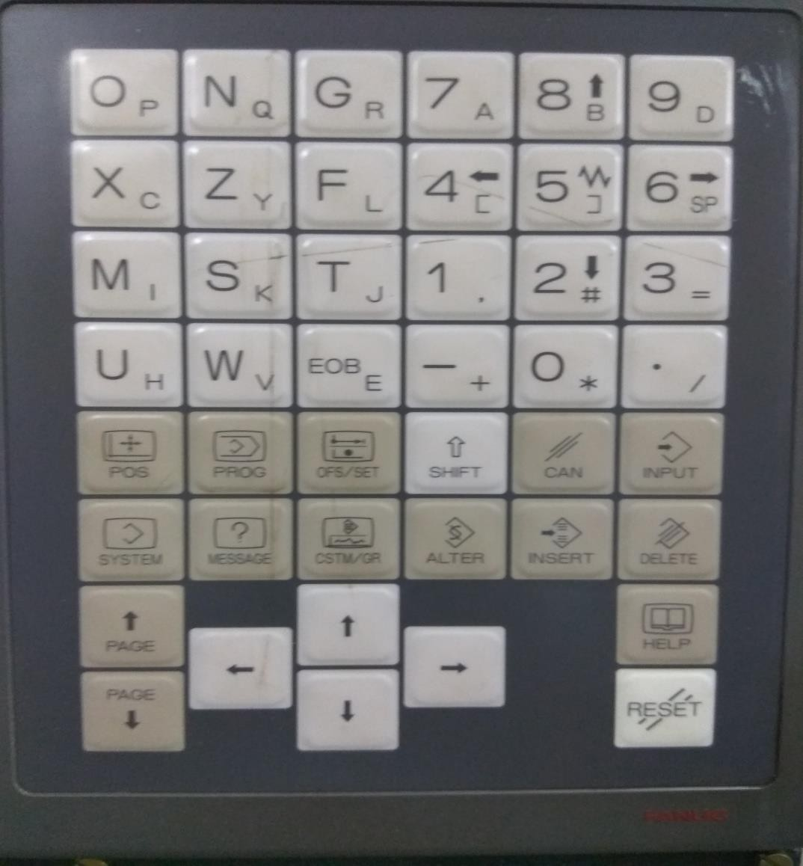

- Message Key: Typical screen that appears in the Message mode relate to various alarms and operation. They may also show alarm history.
- Graph Key: It shows tool path motion graphically. The main benefit of this optional feature is that a program can be graphically tested prior to actual machining.

- Address Keys: These are the keys that contain the letters and secondary characters. Grouping of the letters is designed to be convenient for CNC .Numeric Keyboard: Numeric section of the keyboard contains only primary numbers. It covers all digits from 0 to 9 as well as negative sign and the decimal point.
There is also a symbol for the forward slash, used as a block skip symbol in CNC programming.
- Edit Keys: These are the three keys on the control panel. They are used to edit programs stored in the CNC memory:
  - Alter -- Changes existing program entry.
  - Insert – add a new entry into an existing program.
  - Delete – removes program entry.
- EOB-CAN-INPUT Keys: -
  - EOB is just a short form for the End-of-block character. When entering a part program into a control system in EDIT or MDI mode, each block has to be separated from the next program block. EOB key is used for that purpose.
  - CAN is the Cancel Key. This key is used to cancel an erroneous data entry.
  - INPUT is a special key for data settings. Unlike the INSERT key, it is not used for program data. Its main use to set various offsets, setting parameters etc.
- RESET Key: Pressing the RESET key, many default conditions are restored. One of the most common use this key is to cancel alarm or error conditions.
- Help Key: It provides details relating to various commands- commonly used in MDI mode. Various alarm details, as well as details relating to operation methods and parameter table can be found here.
- Function Keys: These buttons correspond to particular display modes (active modes). By pressing any one of these buttons, the display will be switched to the corresponding screen. Then the soft keys may be used to display the needed data.
  - Press the POS key to display the Position Screen.
  - Press the PROG key to display the Program list screen
  - Press the OFFSET/ SETTING key to display the screen used to set offsets or adjust parameter settings.
  - Press the SYSTEM key to display system screen
  - Press the MESSAGE key to display the message screen
  - Press the GRAPH key to display the graphics screen
SPINDLE
These buttons are used exclusively during the manual operation of the machine for setup functions. The descriptions below explain their specific functions.

Spindle rotation CW: By pressing this button while in one of the Operation modes; HOME, JOG, INC JOG or MPG the spindle will start rotation in the clockwise direction
Spindle Stop: Pressing this button stops the spindle motor rotation while in one of the operation modes listed above. Pressing this button will not stop the spindle while in the execution modes.

Spindle rotation CCW: By pressing this button while in one of the Operation modes; HOME, JOG, INC JOG or MPG the spindle will start rotation in the anti- clockwise direction
Cycle Start: The cycle start button is used to start automatic operation. Use this button in order to begin the execution of a program from memory.
Cycle Stop (feed hold): Pressing the CYCLE STOP button during automatic operation will halt all feed movements of the machine.
Manual Pulse Generator (MPG)
Pressing this button activates the manual handle feed mode for the selected axis. This handle is also known as the Manual Pulse Generator.
CRT Display
This is the television like screen on which all the program characters and data are shown. Sizes may vary from around 9 inches to approximately 15 inches. Displays are colour, monochrome or liquid crystal display (LCD)
Safety Rules For CNC Shop:-
CNC machines have been built- with a safety system that includes guards and other protective devices. These safety devices must be firmly fitted in place at all times when the machine is in use
Below is a list of some general personal safety rules to guide you. You can add any other rule that you feel may apply to you.
DOS:
- Always ensure that you wear hearing protection and a good pair of safety glasses when operating a CNC machine.
- Ensure that your safety glasses are firmly in place every time you are closely observing the cutting tools.
- Ensure that you wear suitable footwear such as safety boots at all times.

- If you have long hair, ensure that you keep it covered when you operate the CNC
machine.
- Keep your hands away from any moving parts during machining processes.
- Stand clear of the machine whenever it is operational. You should also warn any
other people near the risk of being too close to it.
- Whenever you are handling or passing tools, avoid touching the cutting edges.

- Ensure that you turn the machine off completely and clean it whenever you have
finished using it.

DON’TS:
- You should never wear gloves while operating the CNC machine.
- You should never try to reach into the machine while it’s running
- you should never put your hands anywhere near the spindle when it’s revolving.
- Never leave the machine when it’s not completely powered do should never wear jewellery or any loose clothing.
Startup Procedure:
Pre-Start Checks:
Ensure all safety measures are in place.
Verify that the work area is clear of obstructions.
Check coolant and lubricant levels.
Confirm the main power switch is off.
Refer to the machine's manual for specific pre-start checks.
Power Up:
Turn on the main power switch
Turn on the CNC control system.
Mechanical Booster notes that stepper motors are used to drive the slides.
Load Tools:
Load all necessary tools into the tool changer or turret, following the order listed in the CNC Program.

Mount Workpiece:
Secure the workpiece in the vise or clamping system.
Ensure the workpiece is properly aligned and positioned.
Set Offsets:
Set tool length offsets (TLO) for each tool used.
Establish the part origin (XY datum) on the workpiece.
Load Program:
Load the CNC program (G-code) into the machine's control system.
This can be done via USB, floppy disk, or other methods.
Dry Run:
Execute a dry run, simulating the program with the tool a few inches above the workpiece.
This allows for a visual check of tool paths and machine movements before actual cutting.
Run Program:
Once the dry run is successful, initiate the actual machining process.
Monitor and Adjust:
Continuously monitor the machine during operation.
Make any necessary adjustments to offsets or tool paths based on part measurements and Quality check.
Shutdown Procedure:
Stop the Machine:
Stop the machining program using the emergency stop or program stop function.
Retract Tools and Workpiece:
Move the tools and workpiece to a safe position.
Ensure the tools are retracted from the workpiece.
Power Down:
Turn off the CNC control system.
Switch off the main power switch.

Clean and Maintain:
Clean the machine and work area.
Perform any necessary maintenance tasks, such as lubricating moving
Part of CNC Turret : Bad, Chuck, Tailstock, Turret, Guidewayes
Bed:
The bed is the sturdy base of the CNC lathe, supporting all other components.
It's typically made of cast iron or a similar material to ensure stability and dampen vibrations.
Chuck:
The chuck is a clamping device that holds the workpiece securely. It is attached to the headstock and rotates the workpiece during machining operations.
Tailstock:
The tailstock is a moveable unit that provides support for the workpiece, particularly for longer parts. It can be adjusted along the guideways and may house a center or other tools for drilling or reaming.
Turret:
The turret holds multiple cutting tools and rotates to present the correct tool for the machining operation. It enables automatic tool changes, increasing efficiency and productivity.
Guideways:
Guideways are tracks that guide the movement of the carriage (which holds the cutting tool) and the tailstock along the X and Z axes. They ensure precise and controlled movement for accurate machining.

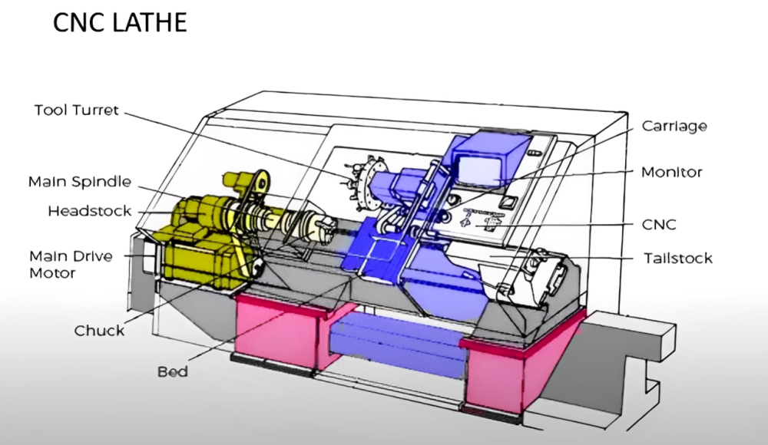

Axis Definitions (X,Z):
CNC turning machine, the X-axis typically represents the horizontal movement
of the cutting tool perpendicular to the spindle axis, while the Z-axis represents
the longitudinal movement of the cutting tool along the spindle axis. Essentially,
the X-axis controls the radial depth of cut, and the Z-axis controls the axial length
of the cut.
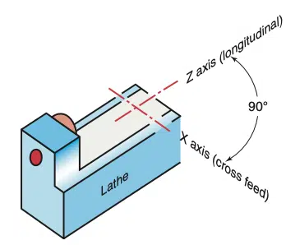

Chuck:
Definition:
  - A chuck is a clamping device used to hold and rotate a workpiece, particularly
  - those with radial symmetry.
Types:
  - Common types include 3-jaw chucks, 4-jaw chucks, and collet chucks.

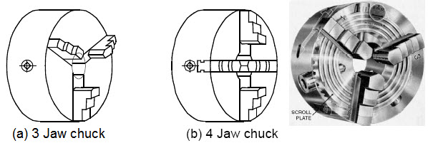

Collet:
Definition:
A collet is a sleeve with a conical inner surface and a cylindrical outer surface. When squeezed, it contracts to grip the workpiece.
Types:
  - Can be internal or external, with internal collets gripping the outer surface
  - and external collets gripping the inner surface.
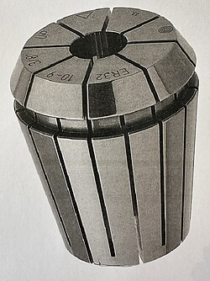
COLLET

- Definition:
  - A fixture is a custom-designed device that securely holds, supports, and locates
  - a workpiece for a specific operation.

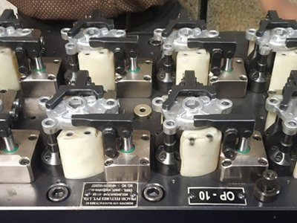
FIXTURE

Tool Holding On Turret:
  - A tool holding system on a turret lathe or CNC machine involves a rotatin turret that holds multiple tools, allowing for quick changes between operations.Tool holders secure the cutting tools within the turret, providing precis positioning and stability. Common types of tool holders include those for turning tools, boring bars, and drilling tools. The turret rotates to bring the desired tool into the cutting position.
Key Components:
- Turret:
  - The rotating part of the machine that holds the tools. In capstan lathes, it's mounted on a slide, while in turret lathes, it's directly on the saddle. In CNC machines, it's a crucial part of the spindle and allows for fast tool changes.
- Tool Holders:
Devices that secure the cutting tools within the turret. These can be designed for different types of tools and offer various clamping methods.
- Tooling:
  - Includes various tools like turning tools, boring bars, drilling tools, and threading tools, each designed for specific operations.

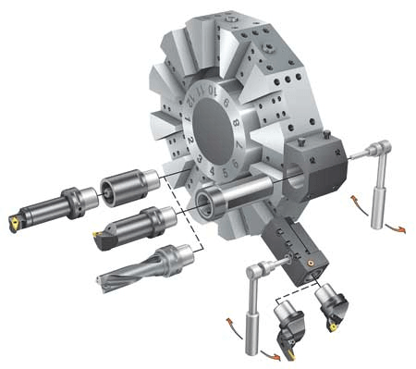

  - TURRET TOOLING

  - Homing & Referencing procedures:
1. Understanding Homing:
  - Purpose:
Homing is crucial for CNC machines as it establishes a known reference point (home position) for each axis. This allows the machine to accurately locate itself within its workspace and execute programmed movements.
  - Mechanism:
Homing involves moving each axis (X, Z on a lathe) until a sensor (limit switch, proximity sensor, etc.) is triggered. This sensor sends a signal to the machine's control system, indicating that the axis has reached its home position.
  - Importance:
Without homing, the machine wouldn't know its position, leading to inaccurate cuts and potential crashes.
2. Homing Procedure:
  - Initiate Homing:
The homing process is initiated through the CNC control panel, often by pressing a "Home" or "Reference" button for each axis or all axes at once.
  - Axis Movement:
The machine will then move each axis (X and Z in a lathe) towards the home position, guided by the pre-configured settings.
  - Sensor Trigger:
When an axis reaches its designated sensor, it stops, and the controller records that position as the zero point for that axis.
  - Offset:
After reaching the sensor, the machine might slightly retract from the sensor (an offset) to prevent accidental triggering during subsequent operations.
  - Completion:
Once all axes are homed, the machine is ready for operation with a defined zero point.
3. Referencing:
  - Workpiece Zero:
While homing establishes the machine's zero point, referencing sets the zero point on the workpiece itself.

  - Offset:
This involves finding a specific point on the workpiece (e.g., the edge, a corner, or the center) and defining it as the workpiece zero, or part zero.
  - 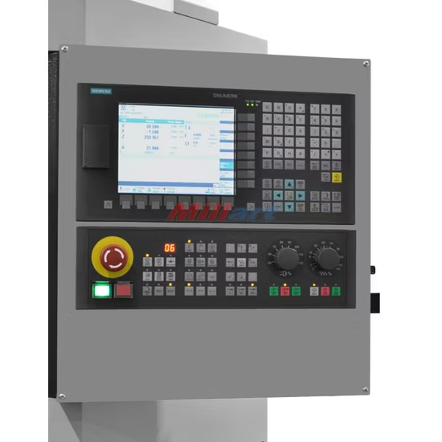
CONTROL PANEL
MDI Mode usage:
MDI (Manual Data Input) mode in CNC machines allows operators to input G-code commands directly into the machine's control system to execute specific actions or run small, manual programs. It's particularly useful for tasks like calling tools, setting spindle speeds, or running simple one-time operations. The MDI mode is accessed through the machine's control panel, and entered commands are executed immediately, either step-by-step or continuously, depending on the settings
Basic G & M Code introduction (G00,G01,m03,m05,etc ) :
G and M codes are the fundamental instructions used in CNC (Computer Numerical Control) programming to control machine tool movements and operations. G-codes, or preparatory codes, primarily control the geometry of the machine's movements, while M-codes, or machine codes, control miscellaneous machine functions.
G-Codes:
- G00 (Rapid Traverse): Moves the tool to a specified coordinate at the machine's fastest speed.
- G01 (Linear Interpolation): Moves the tool along a straight line to the specified coordinates at a programmed feedrate.

M-codes:
- M03 (Spindle Start - Clockwise): Starts the machine's spindle rotating in a clockwise direction.
- M05 (Spindle Stop): Stops the machine's spindle.
Jogging, Spindle Control, Coolant Control
Jogging, spindle control, and coolant control are crucial aspects of CNC (Computer Numerical Control) machine operation. Jogging allows for precise manual movement of machine components, spindle control manages the rotation of the cutting tool, and coolant control ensures proper cooling and lubrication of the cutting area. These functions are typically integrated into the machine's control system

1. Jogging Control:
- Purpose: Jogging enables operators to make small, controlled movements of the machine axes (X, Y, Z, etc.) for setup, tool changes, or precise positioning.
- Implementation: Jogging is usually achieved through dedicated buttons or controls on the machine's pendant or control panel. These controls activate motors to move the axes in small increments, as determined by the control system.
2. Spindle Control:
- Purpose: Spindle control manages the rotational speed and direction of the machine's spindle, which holds the cutting tool.
- Implementation: CNC machines use variable frequency drives (VFDs) or other motor control systems to regulate spindle speed. Operators can set the desired speed in the G-code program or through manual controls.
3. Coolant Control:
- Purpose: Coolant is essential for cooling the cutting tool and workpiece, lubricating the cut, and removing chips. Coolant control manages the flow and type of coolant used.
- Implementation: CNC machines typically have coolant pumps and nozzles. Coolant flow is often controlled by M-codes (e.g., M07, M08 for turning coolant on, M09 for turning it off) within the G-code program.

Emergency Stop and Overrides:
An emergency stop (e-stop) system is a crucial safety mechanism designed to quickly halt machinery or equipment in hazardous situations. It typically involves a readily accessible button that, when activated, immediately cuts power or control signals, bringing the machine to a halt. An override mechanism, if present, allows for controlled restart after the emergency has passed

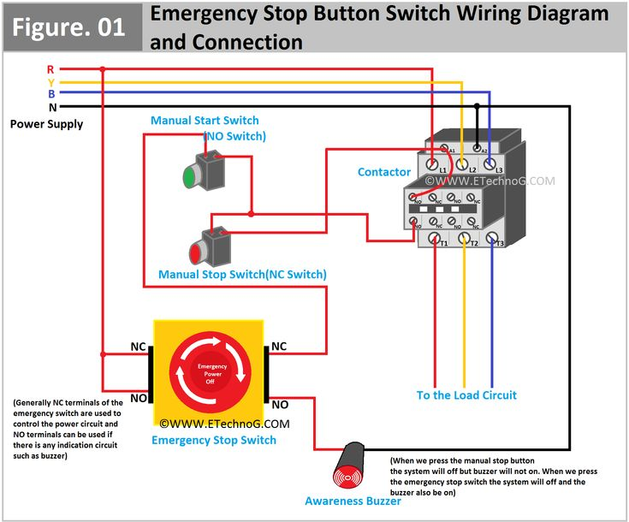

Type of Tools for Turret lathe (Turning, Boring,Grooving,Threading):
Turret lathes utilize a variety of cutting tools for turning, boring, grooving, and threading operations. These tools include turning tools (for external diameter reduction), boring bars (for enlarging internal diameters), grooving tools (for creating grooves or recesses), and threading tools (for cutting internal or external threads).
1. Turning Tools:
- Purpose:
Used for reducing the diameter of a workpiece, creating cylindrical or conical surfaces.

- Types:
Can be single-point tools with various nose radii for different surface finishes and cutting angles.
.2. Boring Tools:
- Purpose: Enlarge existing holes or create new ones in the workpiece.
- Types: Boring bars are available in various lengths and diameters to suit different hole sizes.
3. Grooving Tools:
- Purpose: Cut grooves or recesses of specific widths and depths into the workpiece.
- Types: Grooving tools come in various shapes and sizes to create different groove profiles.
. 4. Threading Tools:
- Purpose: Cut internal or external threads on the workpiece.
- Types: Threading tools include single-point tools for cutting various thread profiles and die heads for cutting external threads.

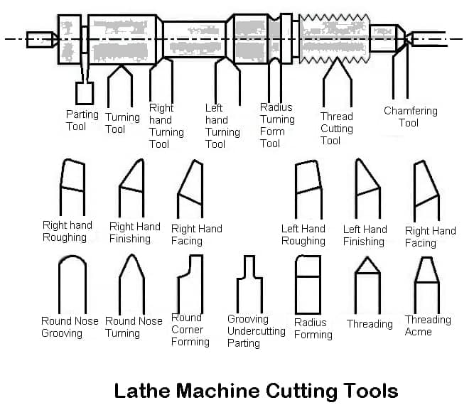

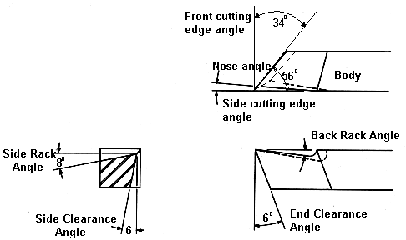

SINGLE POINT CUTTING TOOL

Tool Geometry & Insert Types:
CNC turning machines utilize various insert geometries and tool holder setups to optimize material removal and surface finish during turning operations. Common insert shapes include square, triangular, rhombic, and round, each offering different strengths and applications, such as roughing, finishing, and contouring. Tool holders secure the insert and provide the necessary geometry for specific machining tasks.
CNC Turning Tool Geometry:
- Inserts:
These are replaceable cutting tools that perform the actual material removal. They come in various shapes and sizes, each designed for specific cutting conditions and materials.
- Tool Holders:
These are used to mount the insert onto the CNC machine, providing a rigid platform and often incorporating features like coolant delivery systems.
- Boring Bars:
These are used for making internal cuts, like boring holes, and are essentially long, rigid bars with a cutting edge on the end.

Insert Geometries
- Square:
Provides 8 cutting edges (when negative) and is effective for roughing and some finishing operations.
- Triangular:
Offers 6 cutting edges (when negative) and is useful for machining right angles and copy machining.
- Rhombic (80° and 55°):
Versatile shapes used for external machining and facing, with the 80° being more common.
- Round:
Known for the strongest cutting edge and best surface finish due to the large radius.
Insert Selection Considerations:
- Versatility:
Some shapes, like triangular, are more versatile for different contours.
- Spindle Power:
Certain shapes require more or less spindle power for a given set of cutting parameters.
- Vibration:
Vibration is a key factor and can be minimized by selecting the right insert shape and nose radius.
- Strength:
Round inserts are generally the strongest, while triangular and rhombic inserts can be more prone to fracture.
- Chip Breaking:
The insert shape and nose radius influence how chips break during cutting, affecting surface finish and tool life.
- Depth of Cut and Feed Rate:
Roughing operations typically use larger inserts with bigger nose radii, while finishing uses smaller ones.

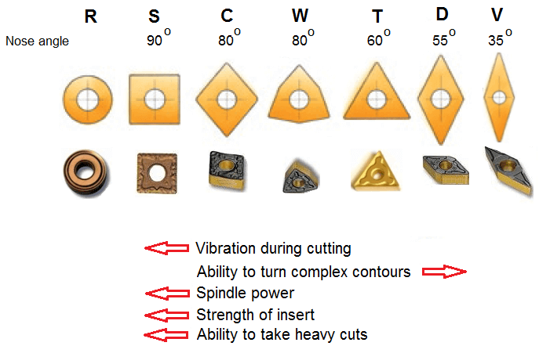
INSERT SHAPE

Tool Setting and Tool Offset Entey:
Setting up a CNC turning machine involves setting tool and work offsets, which are crucial for accurate machining. Tool offsets define the tool's position relative to the machine's coordinate system, while work offsets define the workpiece's position within that system. These offsets ensure that the CNC machine knows the exact location of the tool tip and the workpiece, allowing for precise material removal.
Steps for Setting Tool Offsets:
- Tool Mounting and Alignment: Mount the tool holder and insert into the machine turret, ensuring proper alignment.
- Select Tool Offset Page: Access the tool offset page on the CNC control panel.
- Select Tool Number and Offset Number: Choose the specific tool and its corresponding offset number.
- Manual Mode: Engage manual mode (also called jog mode) to move the tool.
- Touch Off (X-axis): Carefully move the tool to touch the outer diameter of a known diameter workpiece.
- Enter Diameter: Input the known diameter value (e.g., X50.0 if the diameter is 50mm).
- Measure X Offset: Press the "Measure" or "Input" button to store the X offset.
- Touch Off (Z-axis): Move the tool to touch the face of the workpiece.
- Enter Z Offset: Input the Z value (usually 0.0 for the face).
- Measure Z Offset: Press the "Measure" or "Input" button to store the Z offset.

Type of Offset:
GEOMETRY OFFSET-
Geometry offset is use for making job origin or job center at a distance from machine home position.
WEAR OFFSET –
Wear offset is used for shifting the tool from its actual position by giving the value in software. In CNC turning wear offset is used in X&Z axis
WORKSHIFT OFFSET-
Workshift offset is used for shifting the job origin from its actual position by giving the value in software.

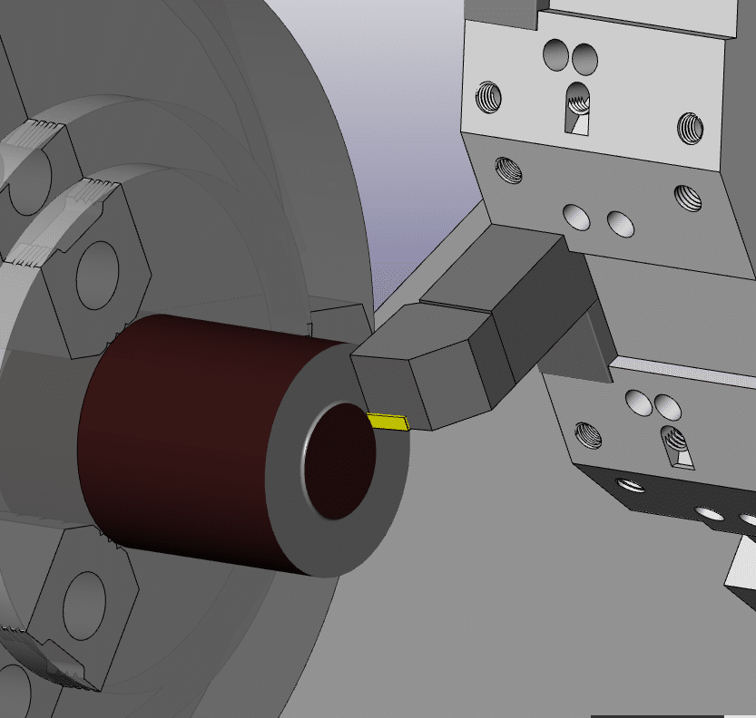

Tool Nose Radius Compensation:
Tool Nose Radius Compensation (TNRC) is a CNC programming technique used in turning operations to ensure accurate machining of complex shapes by accounting for the rounded tip of the cutting tool, known as the tool nose radius. Without TNRC, the radius of the tool tip would cause inaccuracies when cutting taperves.

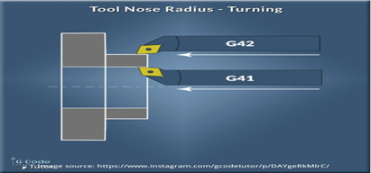

COORDINATE SYSTEM
Coordinate system is used for getting point to point movment of tool according to coordinates of points.
Type of Coordinate:
    - Absolute Coordinate-
The value of any point will be taken with respect to center point.

    - Incremental Coordinate –
The value of any point willo be taken with respect to previous point.

CUTTING SPEED:
The amount of any material removed by the cutting tool in a rotating workpice is called cutting speed.

FORMULA: Cutting Speed (Vc) = ^DN/1000

UNIT: Cutting Speed (Vc) = Meter/minute

RPM:

The revolution made by the spindle in on minute is called RPM.

UNIT:
RPM = Revolution/Minute

FEED:
The distence traveled by the cutting tool in one revolution of the spindle of the machine is called feed.

UNIT:
Feed = MM/Revolution

OR

Feed = MM/Minute

GD&T:
The full form of GD&T is Geometric Dimensioning and Tolerancing .

It is a symbolic language used in engineering drawings to precisely define the geometry and tolerances of an object. This helps ensure precision and control in the manufacturing process.

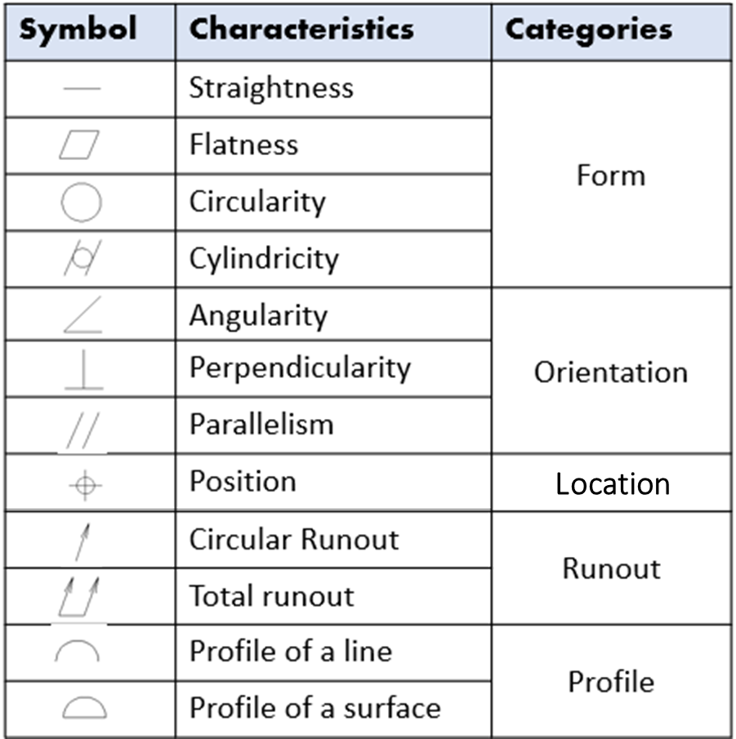

CNC Part Programming Structure:
A CNC part program, which provides instructions to a CNC machine, is structured with a specific order of blocks that include program start, tool setup, spindle and coolant control, movement commands (rapid positioning, linear/circular interpolation), machining operations, and program end. These blocks are arranged to ensure safety, predictability, and readability, using standardized G and M codes.

Here's a breakdown of the common structure:
1. Program Start:
Program Number: Identifies the program (e.g., O0001).
Preparatory Functions (G-codes): Start with G, such as G28 for returning to machine home position and G90 for absolute coordinates.
Tool Selection: Specify the tool number and offset (e.g., T0101).
Spindle Initialization: Turn on the spindle (M03 for clockwise rotation, M04 for counter-clockwise).

Coolant Activation: Turn on the coolant (M07 or M08).
2. Program Content:
Rapid Positioning (G00): Moves the tool quickly to a point near the workpiece.
Linear Interpolation (G01): Moves the tool along a straight line at a specified feed rate.
Circular Interpolation (G02/G03): Moves the tool in a circular path (clockwise or counter-clockwise).
Feed Rate (F): Sets the speed at which the tool cuts the material.
Spindle Speed (S): Sets the speed of the spindle.
3. Program End:
Coolant Shutoff (M09): Turns off the coolant.
Spindle Stop (M05): Stops the spindle.
Return to Home Position (G28): Moves the tool back to the machine's home position.
Program End (M30): Stops the program and rewinds it for the next run.

How to CNC Machine Work:
First, the part program is inserted into the MCU of the CNC.
In MCU all the data process takes place and according to the program prepared, it prepares all the motion commands and sends it to the driving system.
The drive system works as the motion commands are sent by MCU. The drive system controls the motion and velocity of the machine tool.
The feedback system records the position and velocity measurement of the machine tool and sends a feedback signal to the MCU.
In MCU, the feedback signals are compared with the reference signals and if there are errors, it corrects it and sends new signals to the machine tool for the right operation to happen.
A display unit is used to see all the commands, programs and other important data. It acts as the eye of the machine.

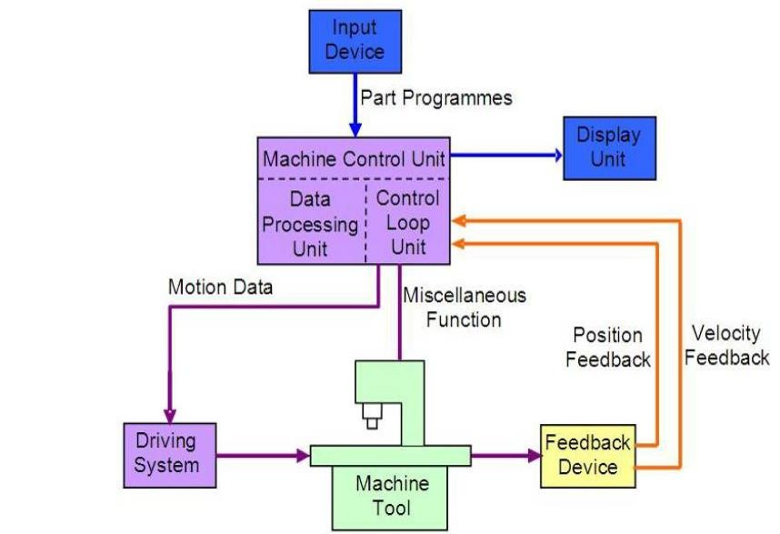

Preparatory Function, G

It prepares the MCU circuits to perform a specific operation. The G is followed by a two or three digit number between 0 and 255. More than one G code can be placed in a block in order to specify all of the setup conditions for an operation.

G – Code List
CNC G codes
G00 - Positioning at rapid speed; Mill and Lathe
G01 - Linear interpolation (machining a straight line); Mill and Lathe G02 - Circular interpolation clockwise (machining arcs); Mill and Lathe G03 - Circular interpolation, counter clockwise; Mill and Lathe
G04 - Mill and Lathe, Dwell G09 - Mill and Lathe, Exact stop
G10 - Setting offsets in the program; Mill and Lathe G12 - Circular pocket milling, clockwise; Mill
G13 - Circular pocket milling, counterclockwise; Mill
G17 - X-Y plane for arc machining; Mill and Lathe with live tooling G18 - Z-X plane for arc machining; Mill and Lathe with live tooling G19 - Z-Y plane for arc machining; Mill and Lathe with live tooling G20 - Inch units; Mill and Lathe
G21 - Metric units; Mill and Lathe
G27 - Reference return check; Mill and Lathe
G28 - Automatic return through reference point; Mill and Lathe
G29 - Move to location through reference point; Mill and Lathe (slightly different for each machine)
G31 - Skip function; Mill and Lathe G32 - Thread cutting; Lathe
G33 - Thread cutting; Mill
G40 - Cancel diameter offset; Mill. Cancel tool nose offset; Lathe

G41 - Cutter compensation left; Tool nose radius compensation left.
G42 - Cutter compensation right; Tool nose radius compensation right.
G43 - Tool length compensation
G44 - Tool length compensation cancel; Mill (sometimes G49) G50 - Set coordinate system and maximum RPM; Lathe
G52 - Local coordinate system setting; Mill and Lathe G53 - Machine coordinate system setting; Mill and Lathe
G54~G59 - Workpiece coordinate system settings #1 t0 #6; Mill and Lathe G61 - Exact stop check; Mill and Lathe
G65 - Custom macro call; Mill and Lathe G70 - Finish cycle; Lathe
G71 - Rough turning cycle; Lathe G72 - Rough facing cycle; Lathe
G73 - Irregular rough turning cycle; Lathe G73 - Chip break drilling cycle; Mill
G74 - Left hand tapping; Mill
G74 - Face grooving or chip break drilling; Lathe G75 - OD groove pecking; Lathe
G76 - Fine boring cycle; Mill G76 - Threading cycle; Lathe
G80 - Cancel cycles; Mill and Lathe G81 - Drill cycle; Mill and Lathe G82 - Drill cycle with dwell; Mill G83 - Peck drilling cycle; Mill
G84 - Tapping cycle; Mill and Lathe G85 - Bore in, bore out; Mill and Lathe G86 - Bore in, rapid out; Mill and Lathe G87 - Back boring cycle; Mill
G90 - Absolute programming G91 - Incremental programming
G92 - Reposition origin point; Mill G92 - Thread cutting cycle; Lathe

G94 - Per minute feed; Mill
G95 - Per revolution feed; Mill
G96 - Constant surface speed control; Lathe G97 - Constant surface speed cancel
G98 - Per minute feed; Lathe
G99 - Per revolution feed; Lathe

M Codes:
M00 - Program stop; Mill and Lathe
M01 - Optional program stop; Lathe and Mill M02 - Program end; Lathe and Mill
M03 - Spindle on clockwise; Lathe and Mill
M04 - Spindle on counterclockwise; Lathe and Mill M05 - Spindle off; Lathe and Mill
M06 – Tool change; Mill
M08 - Coolant on; Lathe and Mill M09 - Coolant off; Lathe and Mill
M10 - Chuck or rotary table clamp; Lathe and Mill M11 - Chuck or rotary table clamp off; Lathe and Mill M19 - Orient spindle; Lathe and Mill
M30 - Program end, return to start; Lathe and Mill M97 - Local sub-routine call; Lathe and Mill
M98 - Sub-program call; Lathe and Mill M99 - End of sub program; Lathe and Mill

GS CATOGORY:

 | GSA | GSB | GSC
Program in inch | G20 | G20 | G70
Thread cutting | G32 | G33 | G33
RPM | G50 | G92 | G92
Feed MM/Minute | G98 | G94 | G94
Feed MM/REVOLUTION | G99 | G95 | G95
Pocket cutting | G90 | G77 | G20
Threading cycle | G92 | G78 | G21
Facing Cycle | G94 | G79 | G24

Steps for CNC Programming and Machining
The following is the procedures to be followed in CNC programming and machining. The most important point is to verify the programme by test run it on the machine before the actual machining in order to ensure that the programme is free of mistakes.

- Study the part drawing carefully.
- Unless the drawing dimensions are CNC adapted, select a suitable programme zero point on the work piece. The tool will be adjusted to this zero point during the machine set up. Determine the machining operations and their sequence. Determine the method of work clamping (Chuck, fixtures etc.).
- Select cutting tools and determine spindle speeds and feeds.
- Write programme (translate machining steps into programme blocks). If many solutions are possible, try the simplest solution first. It is usually longer, but better to proceed in this way. Prepare tool chart or diagram, measure tool geometry (lengths, radii) and note. Clamp work piece and set up machine.
- Enter compensation value if necessary.

- Check and test programme. It is a good practice to dry run the programme (i) without the work-piece, (ii) without the cutting tools, or (iii) by raising the tool to a safe height. If necessary, correct and edit programme and check again.
- Start machining.
PART PROGRAM
A computer program to specify
  - Which tool should be loaded on the machine?
  - What are the cutting conditions (speed, feed, coolant ON/OFF etc)
  - The start point and end point of a motion segment
  - How to move the tool with respect to the machine.
PROGRAM NO- (O 0000 - O 9999) SEQUENCE NO-(N 0000 – O 9999)
BLOCK - G00 X200.0 Z 50.0 (One Block)
WORD - G00 X200.0 Z50.0 (Three words in a block)
ADDRESS – G 00 X 200.0 Z 50.0 (All alphabet in a prog. are the address)
DATA - G 00 X 200.0 Z 50.0 (Any numerals in a block are data)

Some address which is use in program-

ADDRESS | MEANING
A | Angle
C | Chamfer at 45degree.
F | Feed Rate
G | Preparatory function
M | Miscellaneous function
N | Sequence No.
O | Program Number
S | Spindle Rotation
T | Tool Number
X | X-Axis (For Diameter)
Z | Z-Axis (For Length)

Part Drawing:

Part Program:
O0001 | Program number or name
N10 G28 U0.0 W0.0 | Tool return to reference/home position
N20 T0101 | Tool selection of station no.1
N30 G97 M04 S1600 | Spindle start in CCW with 1600 R.P.M
N40 G00 X150.0 Z50.0 | Tool take a safe zone position at point (150,50)
N50 M08 | Coolant on
N60 G00 X25.0 Z2.0 | Tool take cutting position
N70 G71 U1.0 R1.0 | Turning canned cycle
N80 G71 P90 Q160 U0.3 W0.05 F0.15
N90 G01 X10.0 Z0.0 | Coordinates for finishing contour with G-Codes tool motion
N100 G01 X12.0 Z-1.0
N110 G01 X12.0 Z-10.0
N120 G01 X15.0 Z-15.0
N130 G01 X15.0 Z-25.0
N140 G01 X23.0 Z-25.0
N150 G01 X25.0 Z-26.0
N160 G01 X25.0 Z-40.0
N170 G70 P90 Q160 | Finishing Cycle
N180 M09 | Coolant of
N190 G00 X150.0 Z50.0 | Tool take a safe zone position at point (150,50)
N200 M05 | Spindle stop
N210 G28 U0.0 W0.0 | Tool return to reference/home position
M30 | Program End

